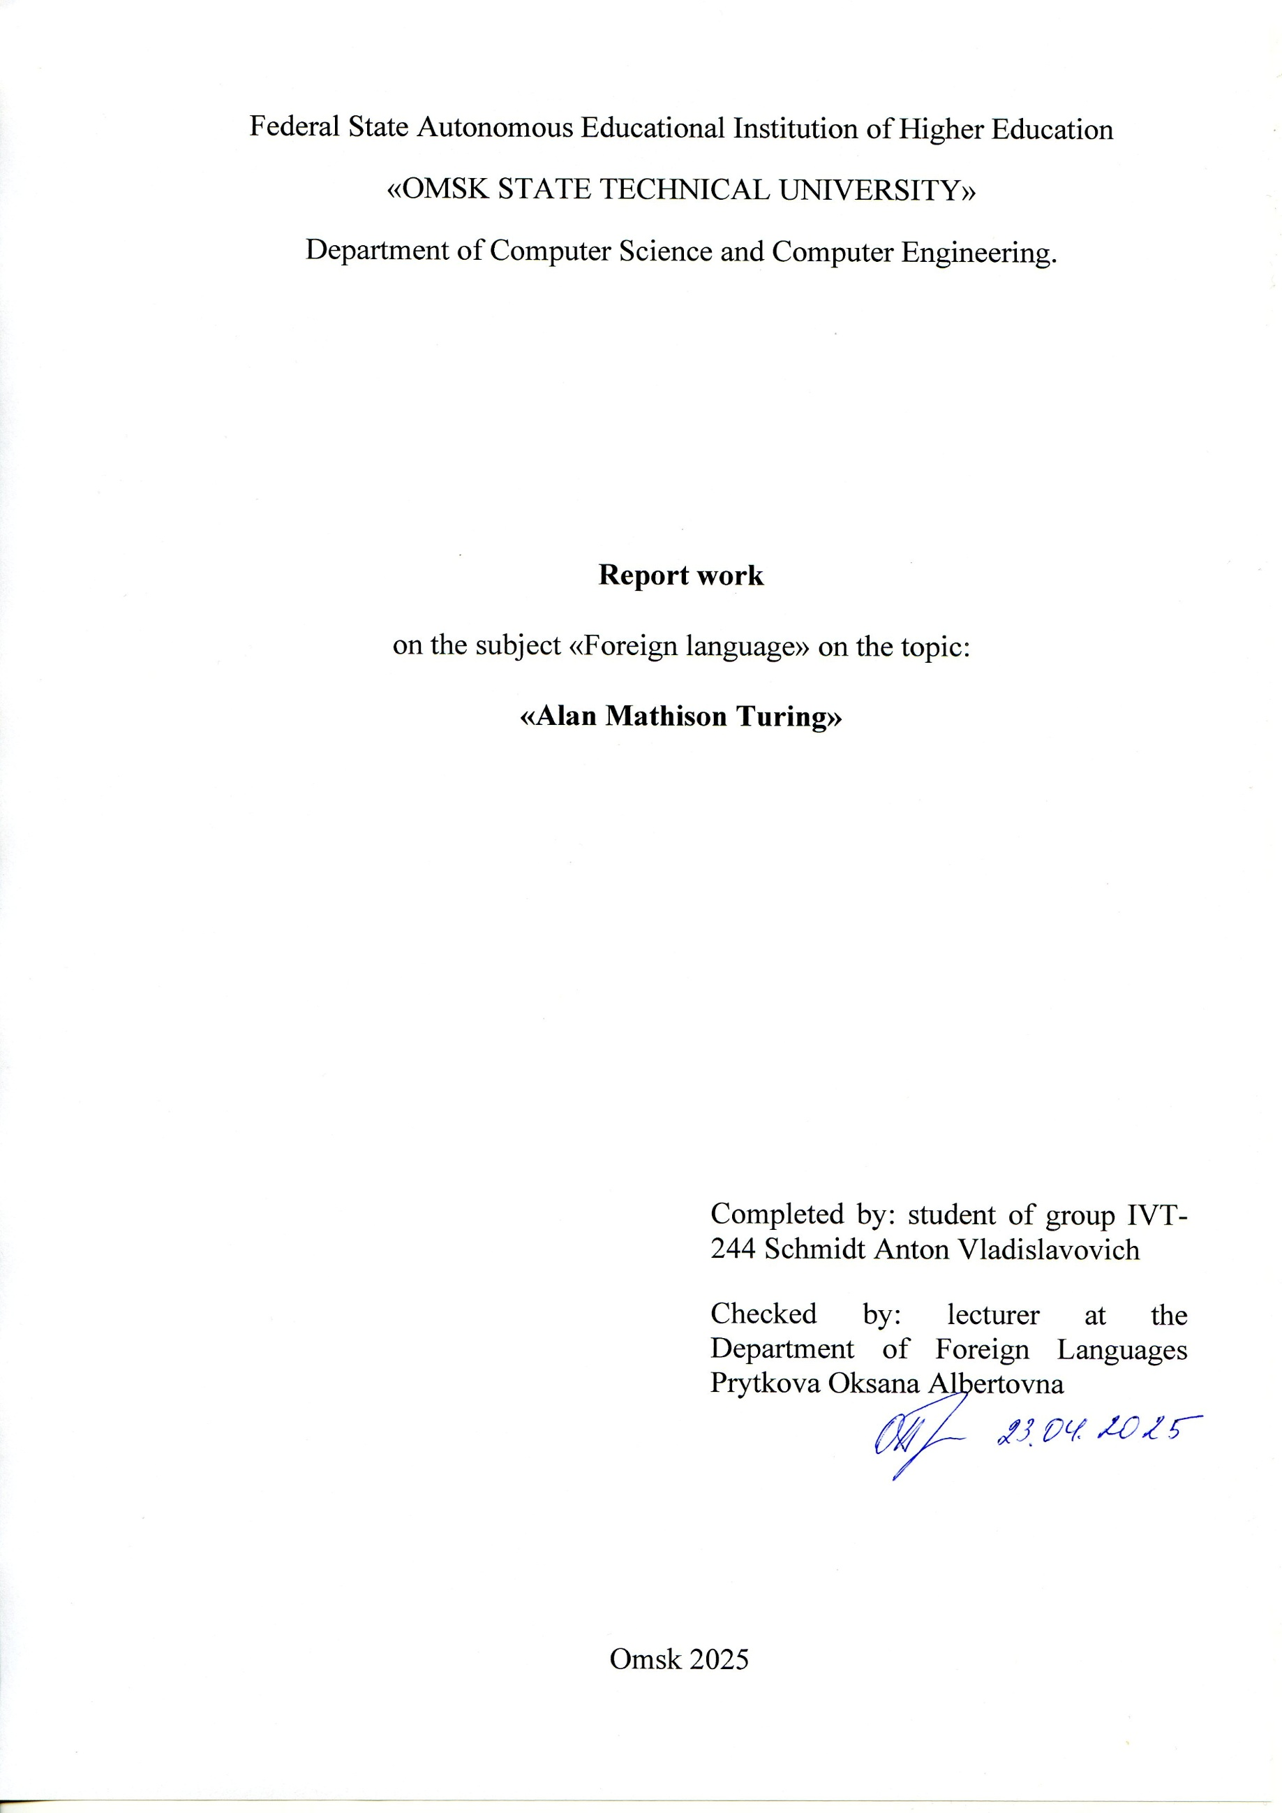
Federal State Autonomous Educational Institution of Higher Education
«OMSK STATE TECHNICAL UNIVERSITY»
Department of Computer Science and Computer Engineering.

Report work
on the subject «Foreign language» on the topic:
«Alan Mathison Turing»

Completed by: student of group IVT-244 Schmidt Anton Vladislavovich
Checked by: lecturer at the Department of Foreign Languages Prytkova Oksana Albertovna

Omsk 2025
Hello everyone. Today, I will tell you about Alan Turing — one of the most brilliant scientists of the 20th century and a true pioneer in the world of computing. We will explore his early life, his greatest invention, his work during World War II, and the legacy he left behind.
Alan Turing — The Father of Modern Computer Science
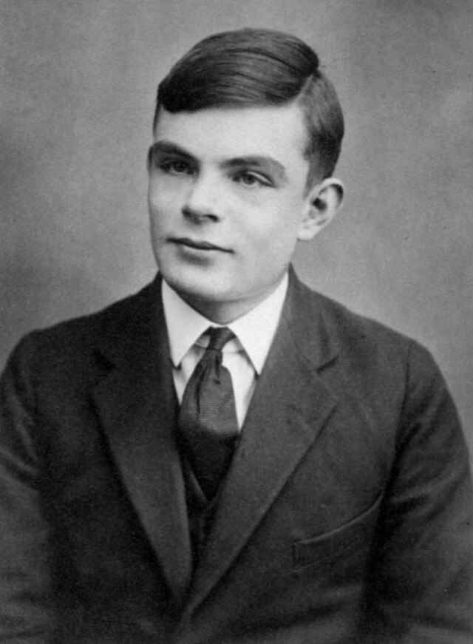
Alan Mathison Turing (1912–1954) was an outstanding British scientist whose ideas laid the foundation of modern computer science, cryptography, and artificial intelligence. His contributions were so significant that many consider him the father of theoretical computer science and a pioneer of digital technology.
Early Life and Education
Alan Turing was born on June 23, 1912, in London. From a young age, he showed remarkable talent in mathematics and logic. He studied at the University of Cambridge and later at Princeton University in the United States. There, he began to ask fundamental questions: Can the process of thinking and calculating be formalized? This question would lead to his most important scientific work.
The Turing Machine — The Theoretical Basis of Computers
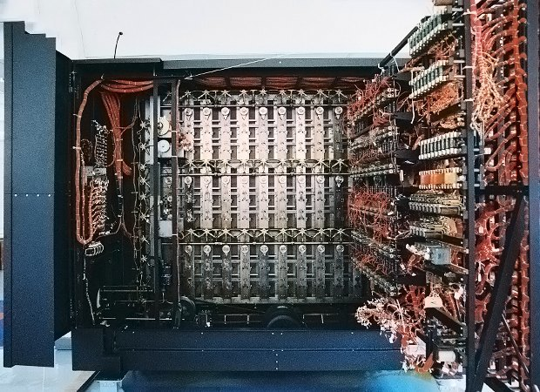
In 1936, Turing published a paper called "On Computable Numbers", where he introduced the concept of an abstract computing machine — now known as the Turing Machine. This model used an imaginary tape and a head that could read, write, and follow rules. Despite its simplicity, it could perform any calculation expressible as an algorithm.
This idea became the cornerstone of algorithm theory and the basis for future programming. Turing's concept marked the beginning of universal computers — machines capable of executing any logical task.
Work During World War II
During World War II, Turing worked at Bletchley Park, the British codebreaking center. He played a leading role in deciphering encrypted German messages created by the Enigma machine — one of the most advanced cipher devices of the time.
To break the code, Turing developed a machine called the Bombe, which could quickly test thousands of Enigma settings. His work allowed the Allies to intercept and understand secret enemy communications, greatly contributing to the war effort and saving countless lives.
Scientific Legacy
After the war, Turing continued to explore ideas in computing and artificial intelligence. He proposed the famous Turing Test — a method for determining whether a machine can exhibit intelligent behavior similar to that of a human. This test is still widely discussed today.
Throughout his career, Turing published important papers on mathematics, logic, and computer science. The Turing Award, one of the highest honors in computer science, is named in his memory and is often considered the "Nobel Prize of Computing."
Conclusion
Alan Turing was not just a scientist — he was a visionary who looked far into the future. His work influenced the outcome of World War II and shaped the digital world we live in today. Modern computers, software, and artificial intelligence all trace their roots back to his revolutionary ideas.
Turing’s legacy continues to inspire scientists and engineers around the globe. His name stands as a symbol of logic, intelligence, and scientific brilliance.

